A Software requirements specification

On

**Online Telephone & Newspaper Billing System**

Submitted in Partial Fulfillment for the Award of Degree of Bachelor of Technology in Computer Science and Engineering from Rajasthan Technical University, Kota



**MENTOR: SUBMITTED BY:**

Ms. Priyanka BhardwajRishi Singhal (19ESKCS800)

(Dept. of Computer Science & Engineering) Ronit Jain (19ESKCS809)

Shobhit Jain (19ESKCS822)

**COORDINATOR:**

Ms. Anjana Sangwan

(Dept. of Computer Science & Engineering)

DEPARTMENT OF COMPUTER SCIENCE & ENGINEERING

**SWAMI KESHWANAND INSTITUTE OF TECHNOLOGY, MANAGEMENT & GRAMOTHAN**

**Ramnagaria (Jagatpura), Jaipur – 302017**

**SESSION 2022-23**

**Table of Contents**

1. Introduction
2. Purpose
3. Objective
4. Definitions, Acronyms and Abbreviations
5. Tools Used
6. Technologies to be used
7. Overview
8. Overall Description
   1. Software Interface
   2. Hardware Interface
   3. Communication Interface
   4. Constraints
   5. E-R Diagram
   6. Use-Case Model Survey
   7. Architecture Design
   8. Database Design
9. References

**Introduction**

* 1. **Purpose**

The purpose of the project is to present the requirement of the Computerization of Telephone Billing System. The project thus calculates the telephone bills automatically. It does almost every work which is related to automatic telephone billing connection system via- new connection , customer record modification, viewing customer records & all works related to rate of bills, meter readings in addition to bill calculation and bill generation. “Telephone Billing System ” is developed as per seeing the increasing requirement to speed up the work and incorporate a new work culture. Thus a new software has been proposed to reduce manual work, improving work efficiency, saving time and to provide greater flexibility and user-friendliness as the system previously followed was totally manual one with lots of errors.

* 1. **Objective**

The main objective while implementing the project Telephone Billing System were to minimize the work and at the same time increase the speed of the work done.

**This new system is built with the following objective**:

* Information retrieval will become easy.
* Maintenance of database as well as overall project will become easy.
* Security measure will be adopted, by maintaining the login of username and the password.
* Data redundancy will be greatly reduced because this new system is built using Visual Basic 6.0 as front-end. It entails looking into duplication of efforts , bottlenecks and inefficient existing procedures

* 1. **Definitions, Acronyms and Abbreviations**
* **Admin (Administrator)**

He has the authority to add/delete/update customers, and update bills of the customers.

* **Customer**

He can log in to the system using their credentials. He can view his telephone bills and data usage, payment status, history, etc.

* **Spring Boot (Java Framework)**

Java Spring Boot (Spring Boot) is a tool that makes developing web application and microservices with Spring Framework faster and easier

* **MySQL (Database)**

It is a database management system that provides a flexible and efficient database platform to maintain records of students, teachers, admin and dm.

* **JSP (Java Server Pages)**

It is used to create dynamic web content.

* **J2EE (Java 2 Enterprise Edition)**

A programming platform which is a part of java platform for developing and running distributed java.

* **UML (Unified Modeling Language)**

It is a standard language for writing software blueprints. The UML may be used to visualize, specify, construct and document

* **XML (Extensible Markup Language)**

It is a text based format that let developers describe, deliver and exchange structured data between a range of applications to client for display and manipulation.

* **HTTP (Hypertext Transfer Protocol)**

It’s a service protocol.

* **V S Code Editor**

Visual Studio Code is a source-code editor made by Microsoft with the Electron Framework.

* **Web Server**

Apache Tomcat (called "Tomcat" for short) is a free and open-source implementation of the Jakarta Servlet, Jakarta Expression Language, and WebSocket technologies. Tomcat provides a "pure Java" HTTP web server environment in which Java code can run.

* 1. **Tools Used**
     1. **Application architecture – JAVA, J2EE**
* **JAVA**

Java is an object-oriented programming language developed by Sun Microsystems a company best known for its high end UNIX workstations. Java language was designed to be small, simple, and portable across platforms, operating systems, both at the source and at the binary level, which means that Java programs (applet and application) can run on any machine that has the Java virtual machine (JVM) installed.

* **J2EE**

Java Platform, Enterprise Edition or Java EEis a widely used platform for server programming in the Java programming language. The Java platform (Enterprise Edition) differs from the Java Standard Edition Platform (Java SE) in that it adds libraries which provide functionality to deploy fault-tolerant, distributed, multi-tier Java software, based largely on modular components running on an application server.

* + 1. **V S Code Editor**

**Visual Studio Code** (famously known as **VS Code**) is a free open source text editor by Microsoft. VS Code is available for Windows, Linux, and macOS. Although the editor is relatively lightweight, it includes some powerful features that have made VS Code one of the most popular development environment tools in recent times. Features include support for debugging, syntax highlighting, intelligent code completion, snippets, code refactoring, and embedded Git.

* + 1. **Spring Boot Java Framework**

Java Spring Boot (Spring Boot) is atool that makes developing web application and microservices with Spring Framework faster and easier through three core capabilities: Autoconfiguration. An opinionated approach to configuration. The ability to create standalone applications.

* + 1. **Database platform – MYSQL**

MySQL is an Oracle-backed open source relational database management system (RDBMS) based on Structured Query Language (SQL). MySQL runs on virtually all platforms, including LINUX, UNIX and Windows. Although it can be used in a wide range of applications, MySQL is most often associated with web applications and online publishing.

* 1. **Technologies to be used**
* **HTML**: Hyper Text Markup Language
* **CSS**: Cascading Style Sheets.
* **JavaScript**: Programming language for web
* **Database Platform** : MySQL
* **Spring Boot** : An open source Java-based framework
  1. **Overview**
* **Existing System:**

The existing system was a manual one. Whatever be the process involved in the system w ere done through register (files) .There were lots of complexities involved in the system. When any customer takes new connections then separate files were maintained. Updating of data was very tedious job. It was not easy to do several administrative works like managing rates of calls, addition or modification of metered calls & customer entries.

* **Drawbacks of existing system:**

In the existing system all the office works was done manually. The manual work processes was time consuming and hence slow. Following are the main drawbacks of the existing system:

• The existing system is totally manual thus there are chances of error in processing.  
• The basic and major drawbacks in the existing system are the speed of retrieval of data from files, which leads to delay.  
• Maintenance of data is very cumbersome and laborious job.  
• The manual jobs such as calculation are more error prone.  
• There are plenty of chances of duplicity of data and information.  
• Updating is very tedious job.  
• There is no central database from where one can get different statistical data at one place.

* **Proposed System:** The new system titled “ONLINE TELEPHONE AND NEWSPAPER BILLING SYSTEM” was hence proposed to remove all the drawbacks discussed above. Information is a vital ingredient for the operation and management of any organization. Thus any system should have the ability to provide error free filtered information after processing the required data. This system has been taken up with a view for developing a more sophisticated system that can be easily handled by any kind of customers. The proposed system aims at efficient and timely information for decision making, integrate with other functions, and reduce redundant work.
* **Important features of this proposed system:**  
  • Consistent user interface with high economic features built into it.  
  • System design in modular and structured way so as to make the integration with other  
  sub systems easier.  
  • User has complete control as it provides and accept only appropriate and valid data.  
  • Customer-friendly error messages are provided wherever necessary.  
  • Addition, deletion, modification of records as when needed.  
  • Providing connections to new customers.  
  • Bill generation for customers

.

**Overall Description**

* 1. **Software Interface**
* **Client on Internet**

Web Browser, Operating System (any)

* **Client on Intranet**

Web Browser, Operating System (any)

* **Web Server**

Apache Tomcat Server , Operating System (any)

* **Data Base Server**

MYSQL, Operating System (any)

* **Development End**
  1. **Hardware Interface**

**Minimum Requirements:**

|  |  |  |  |
| --- | --- | --- | --- |
| **Client Side** | | | |
|  | **Processor** | **RAM** | **Disk Space** |
| Internet Explorer - 6 | Intel(R) Core(TM) i5-1035G1 CPU | 128 MB | 100 MB |

|  |  |  |  |
| --- | --- | --- | --- |
| **Server Side** | | | |
|  | **Processor** | **RAM** | **Disk Space** |
| Spring Boot | Intel(R) Core(TM) i5-1035G1 CPU | 1 GB | 3.5 GB |
| MYSQL 8.0 | Intel(R) Core(TM) i5-1035G1 CPU | 256 MB | 500 MB  (Excluding Data  Size) |

**Recommended Requirements:**

|  |  |  |  |
| --- | --- | --- | --- |
| **Client Side** | | | |
|  | **Processor** | **RAM** | **Disk Space** |
| Internet Explorer - 6 | All Intel or AMD - 1 GHZ | 256 MB | 100 MB |

|  |  |  |  |
| --- | --- | --- | --- |
| **Server Side** | | | |
|  | **Processor** | **RAM** | **Disk Space** |
| Spring Boot | All Intel or AMD - 2 GHZ | 2 GB | 3.5 GB |
| MYSQL 8.0 | All Intel or AMD - 2 GHZ | 512 MB | 500 MB  (Excluding Data  Size) |

* 1. **Communication Interface**
* Client (customer) on Internet will be using HTTP/HTTPS protocol.
* Client (system customer) on Internet will be using HTTP/HTTPS protocol
  1. **Constraints**
* GUI is only in English.
* Login and password is used for the identification of customers and Admin.
* Only registered Customers and admins will be authorized to use the services.
* Limited to HTTP/HTTPS.
* This system is working for single server.
  1. **E-R Diagram**

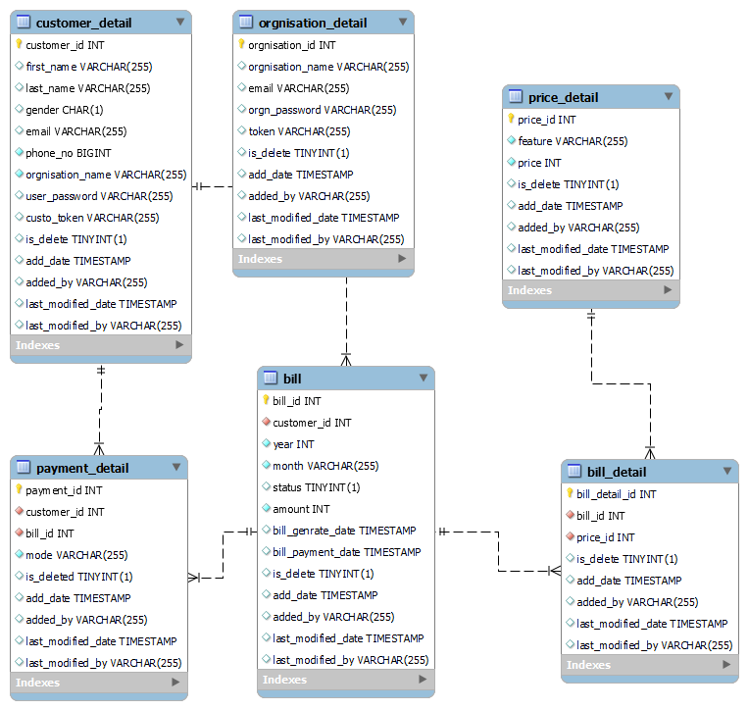

* 1. **Use Case Model Survey**

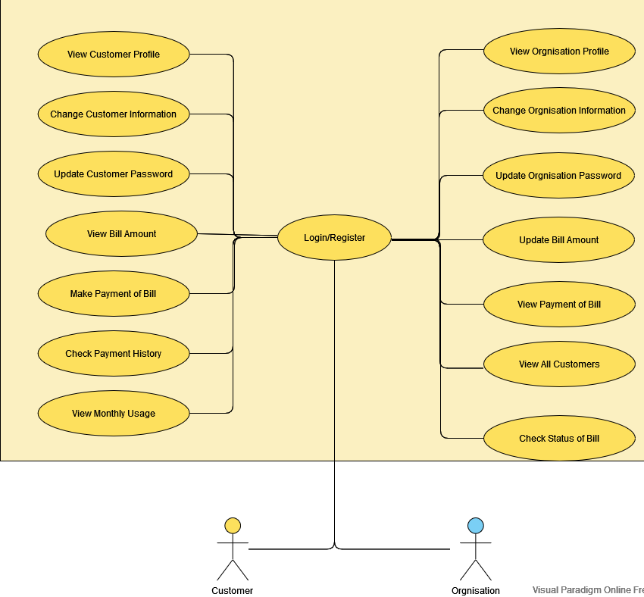

**Fig2.2: Use Case Model Survey**

* **Customers:**

Customer can pay for bills. They can view their bills and payment history. They can change their details and also update their details.

* **Admin:**

Admin update a customer bills and check their pending bills. Admin also can view all customers and their bills and their payment history.

* 1. **Architecture Diagram**

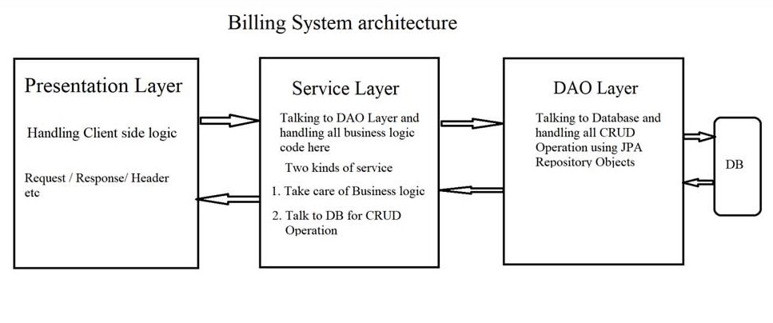

**Fig2.3: Architecture Diagram**

* 1. **Database Design**

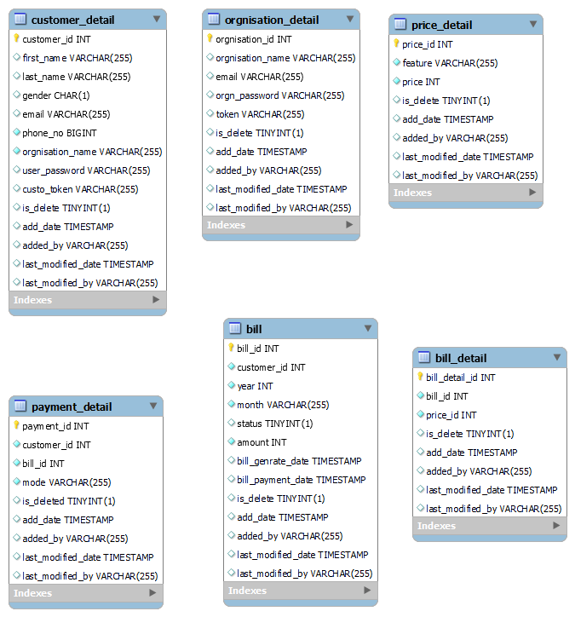

**Fig2.4: Database Design**

**Specific Requirements**

* 1. **Use Case Reports**
     1. **Customer use-case report**

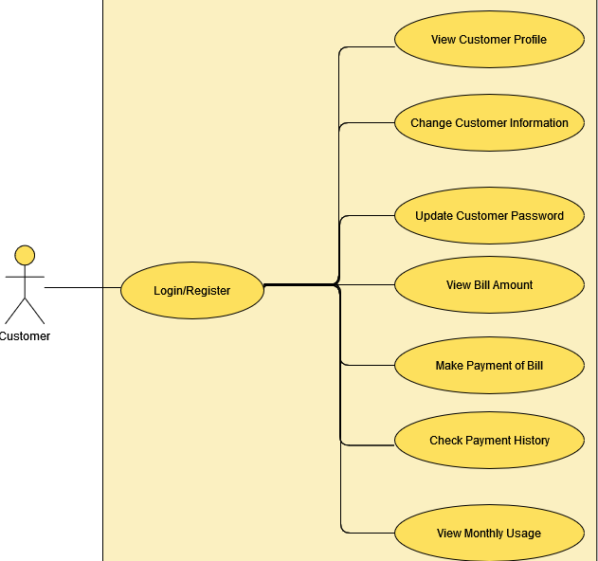

**Fig3.1: Use case diagram for Customer**

|  |  |
| --- | --- |
| **Use Case** | **Description Description** |
| Sign In/Register | The patient has to Login/Register in order to use features. |
| View profile | Every registered customer has his/her own profile containing personal details. |
| Update profile | The customer has the option to update his/her own profile. |
| View bills | The customer can view his/her bill. |
| View bill details | The customer can view his/her bill details. |
| Make payment of a bill | Customer can pay bill of a month. |
| View Payment history | The customer can view his payment history. |
| View monthly usage | The customer can view monthly usage . |
| Change password | The customer can change login password. |

* + 1. **Orgnisation use-case report**

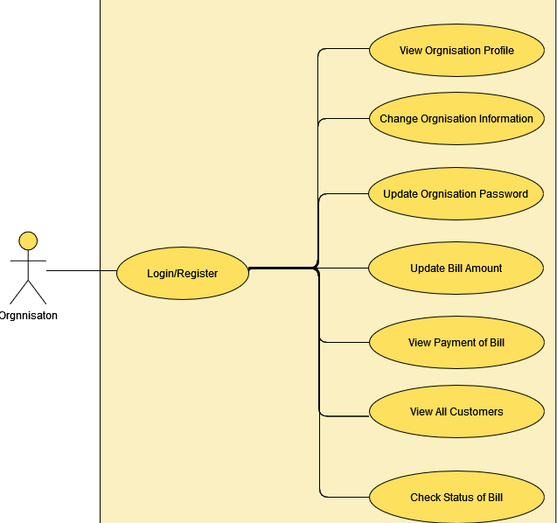

**Fig3.2: Use case diagram for Orgnisation**

|  |  |
| --- | --- |
| **Use Case** | **Description Description** |
| Sign in/Register | The orgnisation has to SignIn?Register in order to start begun his work. |
| View profile | Every registered orgnisation has his/her own profile containing personal and professional details. |
| Update profile | The orgnisation has the option to update his/her own profile. |
| Update customer usage | The orgnisation update the customer usage per month. |
| View all customers | The orgnisation can view all customer of his/her orgnisation. |
| View payment detail of customer | The orgnisation can view payment detail of customer. |
| View customer | The orgnisation can view the customer details. |
| View usage | The orgnisation can view the uusage of a customer bill. |
| Update bill details | The orgnisation can update a customer bill details. |
| Check status of bill | The orgnisation can check the status of a customer bill. |
| Update Feature price | The orgnisation can update the price of a feature |

1. **References**